

MIDDLE EAST TECHNICAL UNIVERSITY

DEPARTMENT OF ELECTRICAL & ELECTRONICS ENGINEERING

EE 463 - Static Power Conversion II - Term Project

Simulation Report

Doge Power Inc.

12V - 100W Isolated DC-DC Converter

Mustafa Yıldız 2233013

Onur Öztaş 2330389

**Table of Contents**

Introduction 2

1. Topology Selection 3

2. Analytical Calculations and Simulations 5

3. Controller Design 8

3.1. Compensator Circuit Design 10

4. Snubber Circuit Design 13

5. Magnetic Design 17

6. Component Selection 17

7. Detailed Simulation Results 18

Conclusion 20

Appendix 20

# Introduction

In electrical drivers, different power levels are required for different applications. Most of the small engines like window engine, wiper engine, air conditioner etc. requires 12V supply. The main power supply, whereas gives 400V input voltage for these applications. Therefore, designing a system that converts high input voltage to a low-level output voltage may need in here. Moreover, in order not to disturb the working performance of the other circuits from the faults may occur in somewhere, isolated systems are crucial. For that purpose, isolated power supplies are designed.

In this project, an isolated switched mode power supply design is conducted. This converter will be able to convert 220V to 400V input voltages to 12V 100W output voltage in a reasonable stability performance. The main duty in this job is to satisfy control loop in a way that system’s both transient and steady state performances are quite good levels.

Throughout this report, first a topology selection is introduced. Then the subsystems of the project steps like controller design, snubber design, thermal design and magnetic design will be introduced one by one. At the end, by giving the simulation results the performance of the designed system can be evaluated.

# Topology Selection

In this project 100W isolated dc-dc converter design is required. In the below, the project specifications are listed as follows:

* Minimum input voltage : 220V
* Maximum input voltage : 400V
* Output voltage : 12V
* Output Power : 100W
* Output voltage peak-peak ripple : 4%
* Line regulation : 3%
* Load regulation : 3%

For the design of such a system, first a suitable topology selection is required. Since the system should be an isolated system, the following topology alternatives can be chosen as follows:

* Flyback Converter
* Forward Converter
* Push – Push Converter
* Half Bridge
* Full Bridge

*Flyback Converter:*

Advantages of this converter are:

* No output inductance requirement
* Ability to supply multiple output voltages
* Less component requirement compared to the other converters

Disadvantages of this converter are:

* Closed loop bandwidth in CCM operation is narrow
* Large output capacitor requirement

Since our input margin is too large, this converter may not give good results in our conditions. Also, it is power ratings are top limit for our specifications. That may result in higher duty cycle requirement. For those reasons, this converter didn’t select.

*Forward Converter:*

Advantages of this converter are:

* Drive circuit is simpler compared to other topologies
* One switching transistor is required

Disadvantages of this converter are:

* Transformer utilization is not sufficient compared to the push pull and bridge topologies. Dmax is limited by 50%.
* Blocking voltage of the transistors are 2 times of the input voltage. That increases ratings of the component.
* It may go into DCM operation

In our design purposes, increasing transformer utilization is critical. Since this topology uses transformer insufficiently, it is not preferred in our design.

*Half Bridge:*

This topology presents best transformer utilization. It provides low cost and small space. However, when controller research is conducted, it is realized that the analog controllers for this topology is not applicable. Most of the controller stabilizes output voltage with respect to reference value. However, the input capacitance middle point is discarded almost all of the controllers. Therefore, due to the insufficient integrated circuits for this topology, it is not selected.

*Full Bridge:*

This topology generally preferred in larger than 500W applications. It has 4 transistors in the primary side of the topology. Since the input voltage level of this project is around 200-400V margin, selecting 4 transistors at those ratings will brings a lot of project costs. Therefore, for that reason this topology is discarded.

*Push – Pull Converter:*

This topology uses 2 input switch and 2 output **diodes**. Moreover, additional LC filter to the output is required. Since its transformer utilization is good, the required transformer core size is relatively small compared to others, and transformer ratings are smaller compared to the Forward. Also, its filter requirement is small compared to the Flyback and Forward topologies. It is one the biggest disadvantage is central top transformer structure. However, while considering the other advantages this converter has more useful for this project. Therefore, this one is selected as a SPMS design application.

# Analytical Calculations and Simulations

Since the topology is Push-Pull, duty cycle should be between 0 and 0.5 because D is used twice during a period. We would like to have charging and discharging durations to be close to each other in order to stay away from discontinuous conduction mode. We set up an xlsx file in order to observe the change in circuit parameters due to frequency, desired duty cycle etc. We set a duty cycle for the input voltage which is the mean of maximum and minimum and calculated Dmax and Dmin accordingly.

metin içeren bir resim

Açıklama otomatik olarak oluşturuldu

Duty cycle will be the controlled parameter in order to keep the output voltage constant with changing input voltage. We calculated the interval of duty cycle.

metin içeren bir resim

Açıklama otomatik olarak oluşturuldu

Since the output side of the push-pull topology is identical to buck converter, output voltage ripple has the same characteristics with half of the period.

metin içeren bir resim

Açıklama otomatik olarak oluşturuldu

As we increase the frequency, we can use smaller components for L and C and reduce the cost. We set the switching frequency at 100kHz.

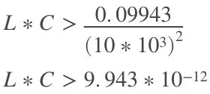

We set L value as 160μH, so C value is calculated as:

metin içeren bir resim

Açıklama otomatik olarak oluşturuldu

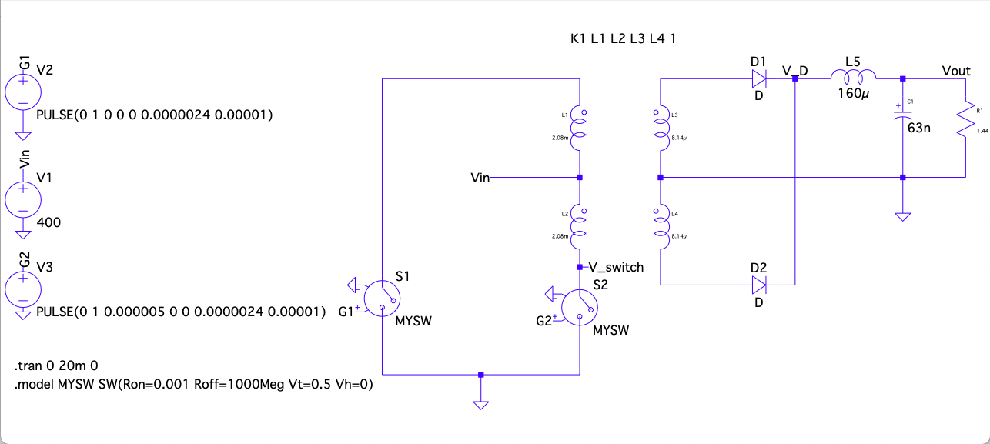

*Figure* ***1****: Circuit Schematic of Push-Pull Circuit without any Control*

tablo içeren bir resim

Açıklama otomatik olarak oluşturuldu

*Figure* ***2****: Output Voltage and Inductor Current Waveforms of Converter*

As seen in Figure **2,** output voltage is in the limits of 4% ripple criteria. Maximum voltage rating of output capacitor should be higher than 12.48V. Maximum current flowing through output inductor should be higher than 8.333A, which can be also calculated as:

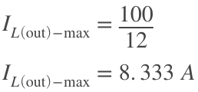

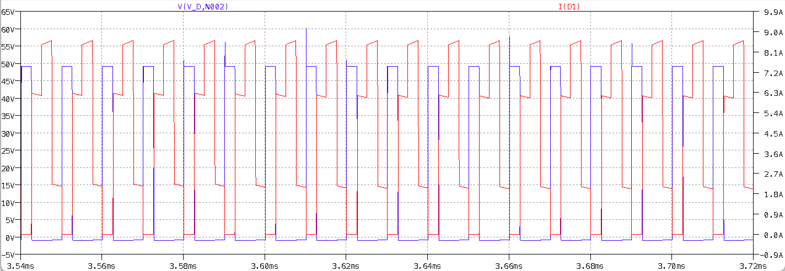

*Figure* ***3****: Voltage and Current Waveforms of DC Side Diodes*

metin, cihaz içeren bir resim

Açıklama otomatik olarak oluşturuldu

*Figure* ***4****: Voltage and Current Waveforms of Switches*

As seen in Figure **3**, diodes should be capable of handling 9A current and 50V reverse voltage. Switches should be able to block at least 800V and conduct more than 800mA according to Figure **4**.

# Controller Design

In this project, stable output is desired whereas input is changing from 220V to 400V. That yields a controller requirement. For this purpose, LT3723-1 current mode controller is selected as it will be expressed in component selection section. This controller can act both as controller and as gate driver for the MOSFETs. Therefore, it decreases the component requirement to a single component. However, the biggest drawback of this controller is that it does not satisfy the isolation criteria of the project. Therefore, in addition to this integrated circuit (IC) an opto coupler and opto coupler driver IC’s is selected, which completes the isolation problem of this design. For opto-coupler MOC207M is selected, for its driver LT1431 IC is selected.

In designing controller, first the main IC should be programmed such that it suits in this application. For step by step improvement, the pin configuration and package information of this IC can be seen in Figure X.

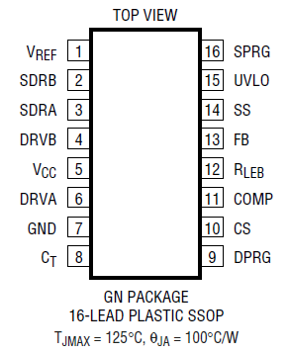

This project is designed with 100 kHz operating frequency. Selecting operating frequency high decreases, the size of the magnetic components and output filter components. However, while frequency increases the switching losses also increases. Therefore, that will yield less efficiency. Finding optimum point is crucial. For that purpose, 100kHz operating frequency is selected. In order to program IC to 100 kHz frequency, its CT pin is used. The following formula programs the operating frequency of the IC by connecting capacitor from that pin to ground.

$$C_{T}=\frac{1}{2*14.8*{10}^{3}*F_{OSC}}$$

$$C_{T}=0.34 nF$$

After inserting this capacitor, the frequency of the gate signals is measured as in Figure X.

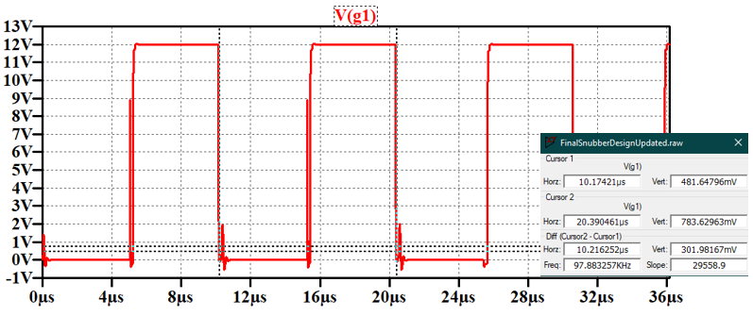

Selecting capacitor value in large significant figures arranges the frequency exactly to the 100kHz. However, in practice it is not practical. Therefore, this amount is decided enough for this application.

In push pull topology, gates of the both MOSFETs are off during some time. That time is known as dead time. Dead time of this IC is programmed with connecting resistances to the SPRG and DPRG pins. The values are determined from the data sheet dead time plot. It is selected as higher as so that it suits in our application. They are selected as 250kΩ. That is enough to stabilize output in the 12V reference level.

Controllers provides controlled output by some external circuits constructed to the control pins. These circuits are known as ‘Compensator Circuits’. Since the control loop in this project is completed by using the opto-coupler circuits, the compensation circuits are constructed in the opto-coupler driver circuit pins. Also, feedback from the output is taken by the opto-coupler driver. Therefore, the feedback pin of the controller is connected to ground. It continuously provides output while compensation signal is provided. In the next subsection the compensator circuit design is explained in detail.

# Compensator Circuit Design

The input voltage range in this application is quite large. Therefore, compensator circuit performance is crucial in order to stabilize output to 12V. There are 3 main compensator types, which are:

* Type I compensator
* Type II compensator
* Type III compensator

Type I is used for basic application. In SMPS designs, type II compensator is preferred generally. However, in large range application that may not be sufficient. In that cases, Type 3 compensator can be used. Since this project conducts in wide range input voltages, it is required to use type 3 compensator. In type 3 design, the following reference circuit configuration is referred.

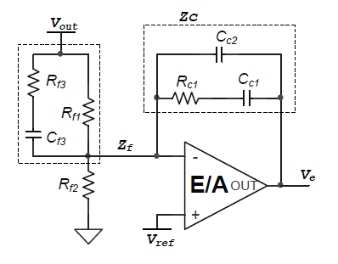

In the design of these components, first pole zero locations are determined. For that purpose, the LC frequency of the output filter is calculated as:

$$F_{LC}=\frac{1}{2*π*\sqrt{L*C}}$$

And, ESR frequency of the capacitor is calculated as:

$$F_{ESR}=\frac{1}{2*π*R_{ESR}*C}$$

The pole-zero locations are selected by these frequencies accordingly as follows:

$$F_{Z2}=F_{LC}$$

$$F_{Z1}=0.75*F_{Z2}=0.75*F_{LC}$$

$$F_{P2}=F_{ESR}$$

$$F_{P3}=\frac{F_{sw}}{2}$$

$$F_{0}≤\frac{F_{sw}}{8}$$

Finally, these is a single pole at the origin, which is $F_{p1}$

The circuit components based on these formulas are calculated from the following formulas based on taking $C_{f3}$ some suitable value, which can be 2.2nF as a good start. If not worked, it can be updated.

$$R_{f3}=\frac{1}{2*π*C_{f3}*F_{p2}}$$

$$R_{f1}=\frac{1}{2*π*C_{f3}*F_{z2}}-R_{f3}$$

$$R_{c1}=\frac{2*π*F_{0}*L_{out}*C_{out}*V_{osc}}{V_{in}*C_{f3}}$$

In here, the $V_{osc}$ voltage is the oscillation voltage of the IC. It is 2.35V from datasheet.

$$C_{c1}=\frac{1}{2*π*R_{c1}*F_{z1}}$$

$$C_{c2}=\frac{1}{2*π*R_{c1}*F_{p3}}$$

These are the general formulas used in the design. However, finding values from these formulas generally not sufficient at first. It required fine tuning algorithms. Calculating again and again from at first step is a messy work. Therefore, as can be seen in Appendix A, a MATLAB m file is prepared.

When the first values are taken, they are simulated. They will stabilize at 12V output in both 220V and 400V input values. However, the final waveform of output voltage at steady state is not sufficient. It is oscillating very high. In order to solve this problem, the transfer function of the compensator circuit is extracted and written into the m file. Then, by plotting bode diagram of that transfer function, the effect of each component indicated above is observed one by one. It is crucial to obtain phase margin larger than 40 degrees. At first, it is around 40 degrees, and as said it is not good for output voltage stabilization. While observing each element effect to the bode plot, it is realized that increasing third pole frequency increases the phase margin of the system, and improves stability also. At final step third pole frequency is selected as:

$$F_{p3}=F_{sw}*2.25$$

It results in -108 degrees phase at 100kHz frequency. It is phase margin is found as:

$$Phase_{margin}=Phase+180$$

$$Phase_{margin}=-108+180=82 degrees$$

The resulted phase margin is excellent for design. Its results are also very good both in terms of transient and in terms of steady state.

# Snubber Circuit Design

In most of the industrial applications, designing circuits with low electromagnetic interference (EMI) is required. The reason for that is designing parts of a project in separately is not affected from this phenomenon because it has an effect to the neighboring components. They usually distort their operating frequencies and also operating performances. Higher EMI problems at some point also distort the operation performance of the product also. Therefore, suppressing those EMI spikes is critical. For that purpose, snubber circuits are preferred. There are 3 types of mostly used snubber circuit configurations. These can be order as:

* C snubber
* RC snubber
* R//D -C snubber

Inserting only C snubbers, decreases system operating speed. When system slows down, then it increases EMI radiation, which is also called ringings. To eliminate ringing R is inserted. In RC snubber that ringing also canceled. Therefore, it yields best result. In another application, resistor is parallel with diode and connected to capacitor in series. The purpose for this application decreasing resistive losses exists in the system. However, since this application works under 100kHz switching frequency, diode’s switching losses are quite high. Also, the cost of the diodes will increase project costs. For that reasons, R-C snubber circuits are used.

Before starting the snubber circuit design, the drain-to-source voltage of MOSFET is observed as in Figure X.

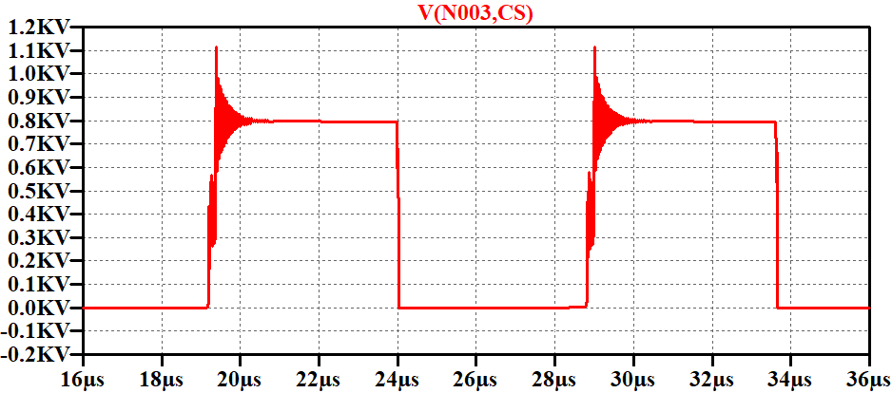

The effect of EMI radiations can be observed easily in this figure. Therefore, eliminating this is critical for SMPS design.

In the design of the snubber circuits, there is a guideline for the push-pull topology. Accordingly, first the resonance frequency of the spikes is measured as shown in Figure X.

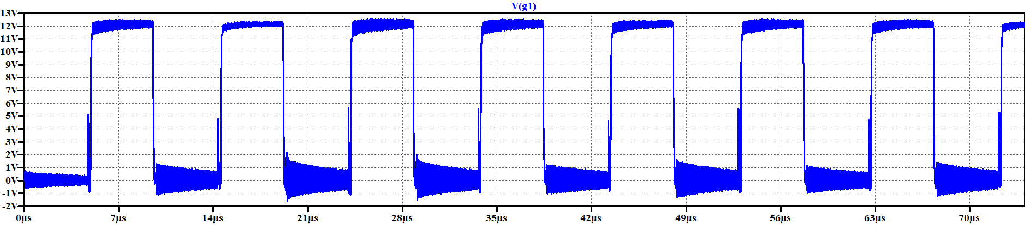

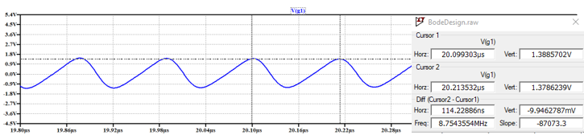

Resonant frequency is measured as 8.75 MHz Insert parallel capacitor to the MOSFET’s drain to source legs so that that frequency drops half of it. The value of the inserted capacitor is 1100 pF that reduces spike frequency by a factor of two. That capacitance is the three times the value of the parasitic capacitance that created voltage spikes.

$$C_{p}=\frac{1100}{3} pF=367 pF (parasitic capacitance)$$

By using this value and the resonant frequency measured as above, the value of the parasitic inductance can be found as below.

$$L=\frac{1}{{\left(2*π*F_{res}\right)}^{2}*C_{p}}=\frac{1}{{\left(2*π*8.75*{10}^{6}\right)}^{2}*367*{10}^{-12}}=9*{10}^{-7}H$$

From these two found values, the characteristics impedance of the resonance can be found as below.

$$Z=\sqrt{\frac{L}{C}}=49.52 Ω$$

From the calculated impedance and capacitor values, the RC snubber circuits component values can be chosen as;

$$R≅Z≅49 Ω$$

$$4*C_{p}<C<10*C_{p}$$

$$1468 pF<C<3670 pF$$

While selecting the snubber capacitance value in found range, the gate signals waveforms observed as insufficient form when $V_{in}$ is 400V. Therefore, in order to fix that problem snubber capacitor for MOSFET is selected as 500pF. It is decided with trial and error way around the found range. It is decided around 3 trial. Therefore, final selected values are:

$$C_{snubber}^{MOSFET}=500 pF$$

$$R_{snubber}^{MOSFET}=45 Ω$$

After inserting snubber components the drain-to-source voltage of the MOSFET’s is observed as in Figure X.

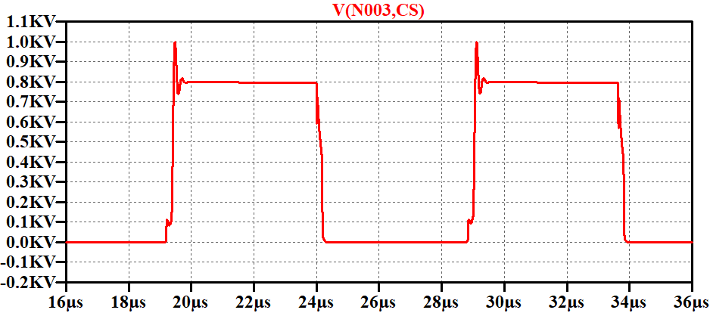

For diode, the same problem is existing. It is voltage waveform can be observed before inserting snubber circuits as in Figure X.

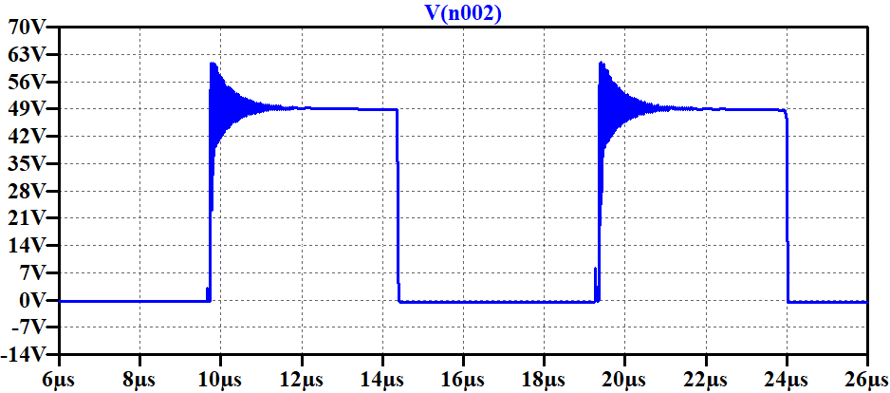

The same procedure applied to the MOSFET’s can be applied for this component also. First resonance frequency of the spike is measured. It is found as 224 MHz Then, by connecting shunt capacitor the value of the parasitic capacitance is found in which the resonance frequency is reduced by a factor of two. Finally, by using the capacitance and resonance frequency values, inductance and reactance values can be found. At the end, almost same of the reactance is selected as snubber resistance, and 200pF capacitance value is selected as the snubber capacitance.

$$f_{spike}=224MHz$$

Capacitance value that reduces spike resonance frequency by half is 100pF. Then, the parasitic capacitance is:

$$C_{p}=\frac{C}{3}=\frac{100pF}{3}≅33pF$$

$$L=1.53*{10}^{-8} H$$

$$Z=21.53 ohm$$

At this point, similar to the MOSFET design, resistor value is selected as found impedance value, and capacitor is selected as:

$$4*C_{p}≤C_{snubber}≤10*C_{p}$$

$$132pF≤C≤330pF$$

Selected exact values are:

$$C_{snubber}^{diode}=200pF$$

$$R_{snubber}^{diode}=22Ω$$

After inserting snubber components, diode voltage waveform is observed as in Figure X.

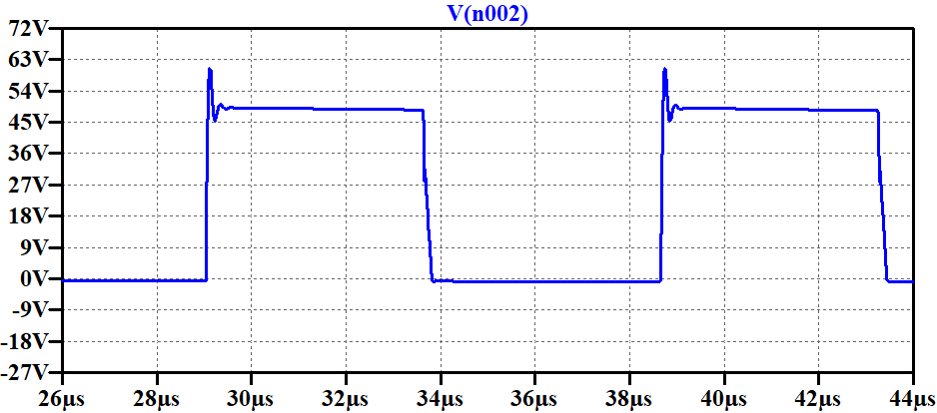

# Magnetic Design

**Transformer Magnetic Design**

**We set 16 as transformer turns ratio. Maximum input voltage is 400V, input frequency is 100kHz, maximum input current is 0.25A and maximum output current is 8.33A. A core should be selected due to stated specifications. We decided to use 2 EER ferrite cores. We checked several cores and calculated required and present window areas and chose PC47EER28-Z. Primary and secondary winding turn numbers are calculated as:**

**metin içeren bir resim

Açıklama otomatik olarak oluşturuldu**

**Required and present window areas are:**

**metin içeren bir resim

Açıklama otomatik olarak oluşturuldu**

**Magnetizing inductance of the transformer should be calculated. As long as we use 2 EER cores, we calculated the reluctance by combining several parts, and then we calculated the magnetizing inductance. Magnetizing inductance is calculated as:**

**metin, cihaz, metre, ölçü aleti içeren bir resim

Açıklama otomatik olarak oluşturuldu**

**metin içeren bir resim

Açıklama otomatik olarak oluşturuldu**

**metin içeren bir resim

Açıklama otomatik olarak oluşturuldu**

**Inductor Magnetic Design**

**An output inductor is needed with capability of handling 8.33A and being larger than 160μH. We checked the cores from the smallest one in order to reduce costs and achieved our criterion at 0W41305TC. Calculations are as follows:**

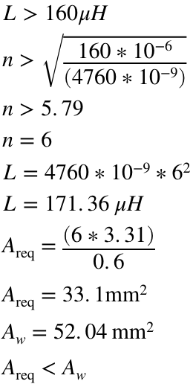

**metin içeren bir resim

Açıklama otomatik olarak oluşturuldu**

# Component Selection

|  |  |  |
| --- | --- | --- |
| Component | Serial Number | Price($) (unit price for purchase of 1000) |
| Controller | LTC3723EGN-1#PBF | 6,48 |
| C8 | MA0805XR474K500 | 0,0095 |
| C9 | GMC04X5R683K16NT | 0,0038 |
| C7 | MA0402XR331K500 | 0,00262 |
| C10 | GMC02X7R102M16NT | 0,0019 |
| C6 | GMC04X7R151K16NT | 0,0032 |
| C1 | 337CKS025M | 0,10051 |
| C2 | GMC04X7R222K50NT | 0,0028 |
| C3 | GMC04CG120J25NT | 0,0018 |
| C4 | GMC04X7R393K25NT | 0,0048 |
| C5 | GMC04CG150J50NT | 0,0019 |
| C12 | GMC21CG201J100NT | 0,027 |
| C13 | GMC21CG201J100NT | 0,027 |
| C14 | 90150 | 0,1532 |
| C16 | 90150 | 0,1532 |
| C17 | 337CKS025M | 0,10051 |
| Transformer Core | PC47EER28L-Z | 0,9576 |
| D1 | STPS30H100DJF-TR | 0,4914 |
| D2 | STPS30H100DJF-TR | 0,4914 |
| Optoisolator | MOC207M | 0,25 |
| Voltage Reference | LT1431CS8#TRPBF | 2,58 |
| C11 | MC04X5R104K25NT | 0,0045 |
| Output Inductor Core | 0W41305TC | 2 |
| M1 | C3M0350120D | 3,5 |
| M2 | C3M0350120D | 3,5 |
| Heatsink 1 | 513301B02500G | 0,83992 |
| Heatsink 2 | 513301B02500G | 0,83992 |
| Thermal Pad | Q3-0.005-00-114 | 0,05 |
| Thermal Pad | Q3-0.005-00-114 | 0,05 |
| Total | | 22,62848 |

*Table 1: Bill of Materials*

We have selected necessary components for our converter application. Table 1 represents the used components and their prices. After choosing all the components, we calculated the losses and conducted detailed simulations which include all the nonidealities.

**Losses**

**Transformer**



**Diodes (Calculated for One)**

**metin içeren bir resim

Açıklama otomatik olarak oluşturuldu**

**MOSFETs (Calculated for One)**

**metin içeren bir resim

Açıklama otomatik olarak oluşturuldu**

**Output Inductor**

**metin içeren bir resim

Açıklama otomatik olarak oluşturuldu**

**Integrated Circuits**



**Thermal Circuit*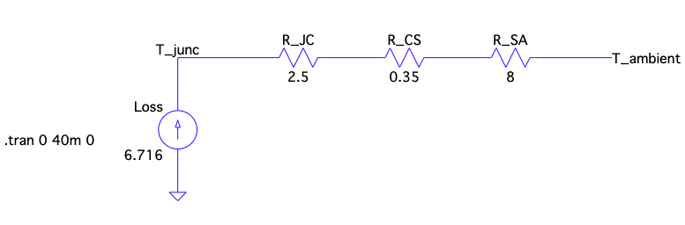***

*Figure X: Thermal Circuit of MOSFET and Heatsink*

Heatsink is needed for the MOSFETs. Maximum temperature for MOSFET operation is 150oC according to datasheet and we want to have a smaller but close junction temperature in order to use a cheaper heatsink. We chose 513301B02500G model of Aavid, Thermal Division of Boyd Corporation which has 8oC/W thermal resistance. Thermal circuit is shown in Figure X. We are using natural cooling. Junction temperature is 98oC with the heatsink.

**metin içeren bir resim

Açıklama otomatik olarak oluşturuldu**

# Detailed Simulation Results

When input voltage is 220V, the output voltage and power waveform is as shown in Figure X.

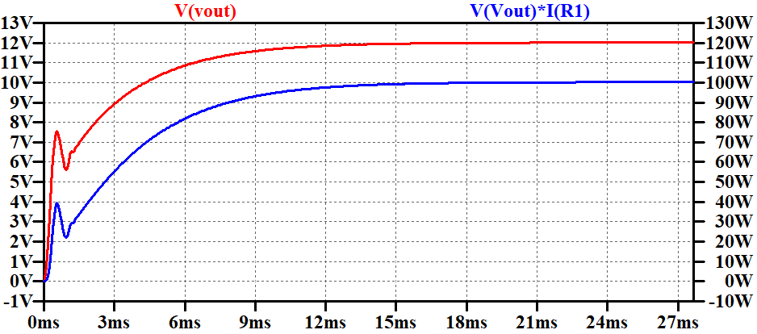

Output voltage stabilizes at 12.02V. The output voltage ripple can be seen in Figure X.

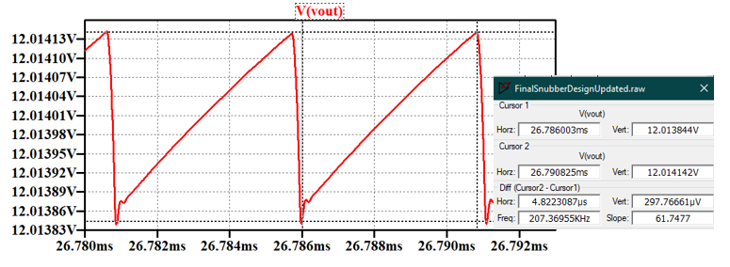

From no load to full load the output voltage waveform can be seen in Figure X.

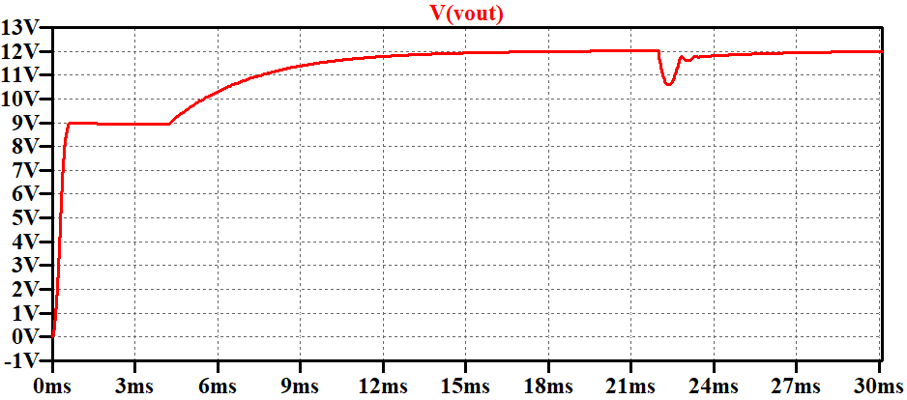

When input voltage is 400V, the output voltage and power waveform is as shown in Figure X.

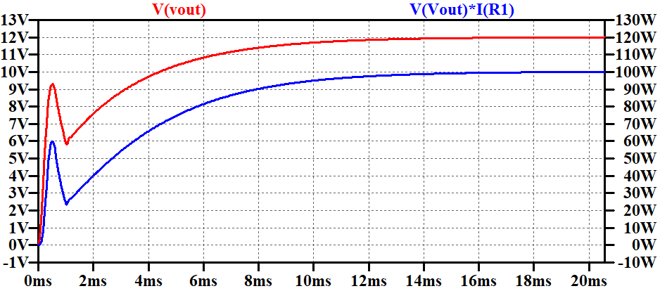

The output voltage stabilizes at 12.0014V.

The output voltage ripple can be seen in Figure

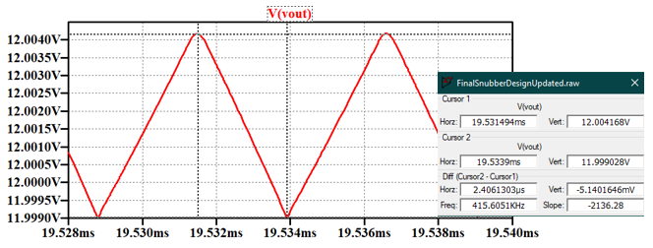

From no load to full load the output voltage waveform can be seen in Figure X.

**tablo içeren bir resim

Açıklama otomatik olarak oluşturuldu**

The line regulation when input voltage changes from 220 V to 400 V can be calculated from the above results as:

$$Line_{reg}=\left(\frac{V_{out}^{220V}-V_{out}^{400V}}{V_{out}^{220V}}\right)*100=\frac{12.02-12.0014}{12.02}*100=0.155\%$$

# Conclusion

# Appendix

%Doge Power Compensator Design File

L = 80e-6; %Output Inductance

C = 330e-6; %Output Capacitance

ESR = 56e-3; %Capacitor ESR value

F_lc = 1/(2*pi*sqrt(L*C)); %Filter frequency

F_esr = 1/(2*pi*ESR*C); %ESR frequency

Fsw = 100e3; %Switching frequency

Fzero = Fsw/10; %Center frequency

Vref = 2.5; %Driver reference voltage

Vout = 12; %Output voltage

Vosc = 2.35; %Peak-to-Peak oscillator amplitude voltage

Vin = 300; %Minimum input voltage

%Type 3 Compensator pole and zero frequencies

Fz2 = F_lc; %Second zero frequency

Fz1 = 0.75*F_lc; %First zero frequency

Fp2 = F_esr*10; %Second pole frequency

%Fp3 = Fsw/2; %Third pole frequency

Fp3 = Fsw*2.25; %Third pole frequency

%Type 3 Compansator Parameters

Cf3 = 2.2e-9; %Cf3 is selected then rest is calculated from it

Rf3 = 1/(2*pi*Cf3*Fp2); %Voltage division compensator Rf1 = 1/(2*pi*Cf3*Fz2)-Rf3; %Voltage division top resistor Rf2 = (Rf1*Vref)/(Vout-Vref); %Voltage division bottom

resistor

Rc1 = (2*pi*Fzero*L*C*Vosc)/(Vin*Cf3); Cc1 = 1/(2*pi*Rc1*Fz1);

Cc2 = 1/(2*pi*Rc1*Fp3);

%Type 3 Compensator Transfer Function s = tf('s');

H = tf([(Rc1*Cc1+Rc1*Cc1*Cf3*(Rf1+Rf3)) (1+Cf3*(Rf1+Rf3))], [(Cc2*Rc1*Cf3*Rf3*Cc1*Rf1) (Cc1*Rf1*Rc1*Cc2+Cc1*Rf1*Rf3*Cf3) (Cc1*Rf1)

0 0]);

bode(H);

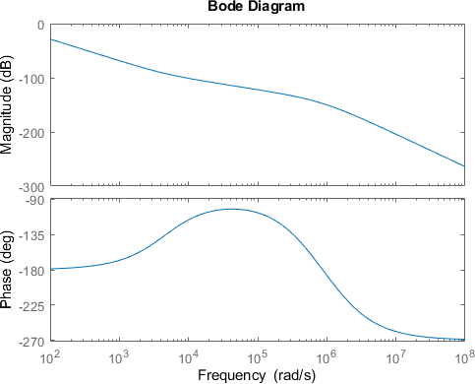

*Published with MATLAB® R2020b*